**COMMITTEE OF THE CHAIRMEN OF THE EIGHT (8) BRANCHES OF THE NIGERIAN BAR ASSOCIATION**

* **(NBA) IN RIVERS STATE**

***C/o NBA PH Branch***

***NBA Port Harcourt House***

***No.1 Bank Road***

***Port Harcourt.***

*08033091301*

***August 3, 2018.***

The Chairman,

Electoral Committee of the Nigerian Bar Association (ECNBA),

NBA House,

National Secretariat,

Plot 1101MohammaduBuhari Way,

Central Business District,

Federal Capital Territory, Abuja,

Nigeria.

Dear Sir,

**DEMAND FOR REVIEW OF THE ONGOING VERIFICATION EXERCISE FOR THE 2018 NBA ELECTION**

As the Chairmen of the Eight (8) Branches of the Nigerian Bar Association (NBA) in Rivers State, we draw your attention to the grave and unbelievable challenges being faced by members of our various Branches with the current electoral process and respectfully urge you to review the ongoing verification exercise for the Nigerian Bar Association (NBA) Election scheduled to hold on the **6th** and **7th August, 2018**.

At no time in our history, have we witnessed the level of confusion, difficulty and outright attempt to disenfranchise eligible and valid voters to participate in their own election. The process has been at best nightmarish and unworkable.

Till date, 95% of members from our Branches have not been able to verify and stand no chance of being so verified before the election and will therefore not be able to vote in the election. In the case of NBA Okrika Branch, the Branch and its entire membership are excluded.

Our point and real concern is how can you sincerely and honestly hold or conduct any meaningful election if qualified and willing voters cannot vote.

We have about 4,000 members in the 8 Branches and we will face intense pressure, dissent and ridicule if these members are disenfranchised.

In order to avert a major crises in our branches and in the NBA generally, we strongly demand that you revisit the entire verification exercise and the election until such a time that you can guarantee openness, a workable process and full participation of all our eligible members.

We hope that you will heed our demand herein.

Yours Sincerely,

**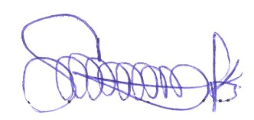*For the Eight(8) NBA Branches in Rivers State;***

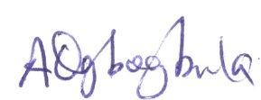

……………………………………………… ………………………………………………

**Sylvester Adaka, Esq. Abbot Ogbogbula, Esq.**

Chairman, NBA PH Branch. Chairman, NBA Ahoada Branch.

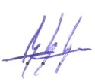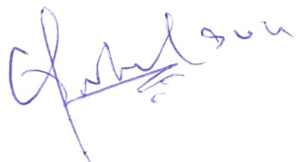

……………………………………………… ………………………………………………

**Godson Owhoji, Esq. N. K.Saronwiyo, Esq.**

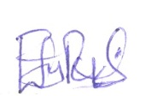Chairman, NBA Isiokpo Branch. Chairman, NBA Bori Branch.

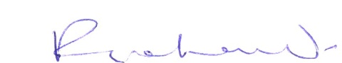

……………………………………………….. …………………………………………………

**Eucharia S. Pepple, Esq. Prof.Ritchard A.Nwokocha**

Chairman, NBA Degema Branch. Chairman, NBA Omoku Branch.

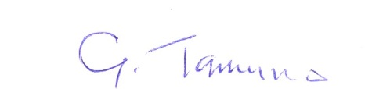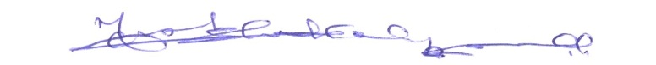

………………………………………………. …………………………………………………

**Dr.Felix C. Amadi Golden O. Tamuno, Esq.**

Chairman, NBA OkehiBranch. Chairman, NBA Okrika Branch.

Cc:

1. **Chief Richard Akinjide, CON, SAN.**

E-mail: [akinjideco@metrong.com](mailto:akinjideco@metrong.com)

1. **Chief Charles IdehenEsq.**
2. **Chief (Mrs)PrisciliaKuye**

[**priscillakuye@hyperia.com**](mailto:Priscillakuye@hyperia.com)

1. **Chief T. J. O. Okpoko, OON, SAN.**

[**okpoko@okpokolawpractice.com**](mailto:okpoko@okpokolawpractice.com)

1. **Hon.O.C.J. Okocha, MFR, SAN, JP.**

[**manuchim@yahoo.com**](mailto:manuchim@yahoo.com)

1. **Chief Sole Olanipekun, OFR, SAN.**

[**info@woleolanipekun.com**](mailto:info@woleolanipekun.com)

1. **Chief BayoOjo, CON, SAN.**

[**cabayoojo@aol.com**](mailto:cabayoojo@aol.com)

1. **Prince LankeOdogiyan**

[**lankeodogiyon@yahoo.com**](mailto:lankeodogiyon@yahoo.com)

1. **OlisaAgbakoba, SAN.**

[**olisa@alisaagbakoba-associates.com**](mailto:olisa@alisaagbakoba-associates.com)

1. **His Excellency, OluwarotimiOdunayoAkeredolu, SAN.**

[**olujinmiakeredolu@yahoo.co.uk**](mailto:olujinmiakeredolu@yahoo.co.UK)

**(11.) J. B. Daudu, SAN.**

[daudu@hotmail.com](mailto:daudu@hotmail.com)

1. **Hon.Okey E. Wali SAN, DSSRS**

[okeywaliandco@yahoo.com](mailto:okeywaliandco@yahoo.com)

1. **Augustine Alegeh, SAN.**

[alegeh@yahoo.com](mailto:Alegeh@yahoo.com)

1. **A.B. Mahmoud, SAN.**

NBA President